**Git Assessment**

**Employee:** Jingguo Jiang

E-mail: Jingguo.jiang@errigal.com

**1. What is GIT? Give a brief general description of what Git is and what it does.**

**Existing Implementations**

Many successful implementations such as WhatsApp, Airbnb, etc. can be seen in nowadays. WhatsApp is able to allow you to send your location to others; Airbnb can help you find the accommodations nearby according to location information; Allstate's GoodHome app shows homeowners a personalized risk assessment of their properties.

**Goals of My Service**

In my project, I will implement the LBS based on Android GPS, FourSqure API and Google Map into one small application. On this application, a user can shake the mobile to trigger search results of the places of interests. These results will be displayed on Google Map as well. The prototype is shown on below:

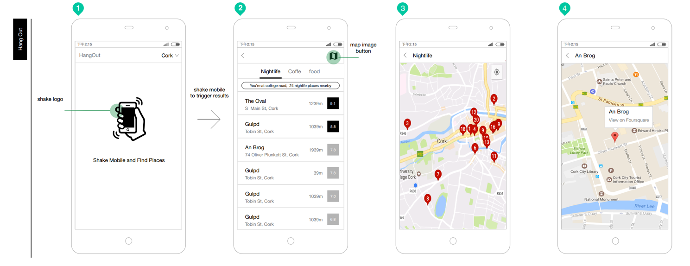

**Project Requirements**

As seen in the above prototype, specific functional requirements can be identified:

1. User can open the app to obtain location information (e.g. Cork) on the status bar.
2. User should be able to shake mobile phone to trigger this app to find the places.
3. The second screen of this app can display search results.
4. User should be able to filter search results based on three tabs (Nightlife, Coffee and food).
5. User can find locations on Google Map (both multiple spots and single one).

This project will also consider some non-functional requirements:

1. The efficiency and fault-tolerance of the service
2. The service can be easily understood and be used by users without many efforts.
3. The development environment and language: Android Studio, Java
4. Ability of quick response is required.

In this project, I intent to achieve non-functional (2,3.4) requirements.

**Problems Need to be Solved**

1. How to develop the shaking functionality based on usage of accelerator senor

This functionality involves senor usage and action animation. The following reference can be used to solve this technical issue.

* <https://developer.android.com/guide/topics/sensors/sensors_overview.html>
* [http://androidexample.com/Accelerometer_Basic_Example_Detect_Phone_Shake_Motion/index.php?view=article_discription&aid=109](http://androidexample.com/Accelerometer_Basic_Example_-_Detect_Phone_Shake_Motion/index.php?view=article_discription&aid=109)

2. How to display locating information in the status bar and on Google Map

I have to look up some information about GPS and LocationManager class to crack this problem. So the following ones can be a good reference:

* <https://developer.android.com/training/location/index.html>
* <http://www.androidhive.info/2012/07/android-gps-location-manager-tutorial/>
* <http://techlovejump.com/android-gps-location-manager-tutorial/>
* <https://developer.android.com/training/maps/index.html>

3. How to use third-party FourSquare API

To obtain FourSquare API, I have to setup an account of FourSquare and get the permission. I also need to study the API documents and samples to use interface to obtain data.

* <http://www.londatiga.net/featured-articles/how-to-use-foursquare-api-on-android-application/>
* <https://developer.foursquare.com/>

**Provisional Schedule**

